6A^{th} Grade: Unit 5, Lesson 4

- If a car travels 12 miles in 6 minutes, what is the unit rate in miles per minute?

2 miles / 1 minute

- Complete the table by determining the amount of balloons needed to lift a 15 pound lb. desk.
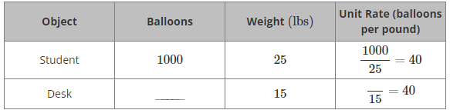

600

- Suppose the unit rate for the number of balloons that can lift objects off of the ground to their weight is 8 balloons to 1 pound (lb.). How many pounds can be lifted by 64 balloons?

8 lbs

